Department of Statistics

The Wharton School

University of Pennsylvania

Statistics 603 August 2011
Assignment 1

1. True or False?

- A meandering time series will yield a bell-shaped histogram.
False, there is no reason why a meandering time series would necessarily yield a bell-shaped histogram. What is true is that a sequence of independent draws from a normal population will probably yield a bell shaped histogram. However, such a sequence will most likely not have a meandering appearance if plotted in time order.

- The normal distribution is symmetric about its mean.
True, the normal distribution is symmetric, and the mean of any symmetric distribution coincides with the center of symmetry.

- log(3)-log(2) = log(6)-log(4).
True, log(3) – log(2) = log(3/2) = log(6/4) = log(6) – log(4).

- Salary distributions are left-skewed.
False, as illustrated by the Forbes data in class, salary distributions tend to be right-skewed.

- The center bar in a boxplot shows the 50’th percentile.
True, the center bar is the median, and the median is the 50’th percentile.

- The height of a histogram bar shows the variability of the data in that interval.
False, the height of the histogram bar shows the frequency count.

2. d) The histograms below show that RentTotal is right skewed whereas Log10RentTotal is much more bell shaped.

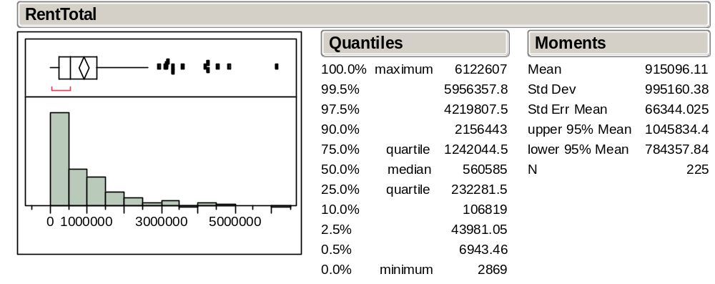

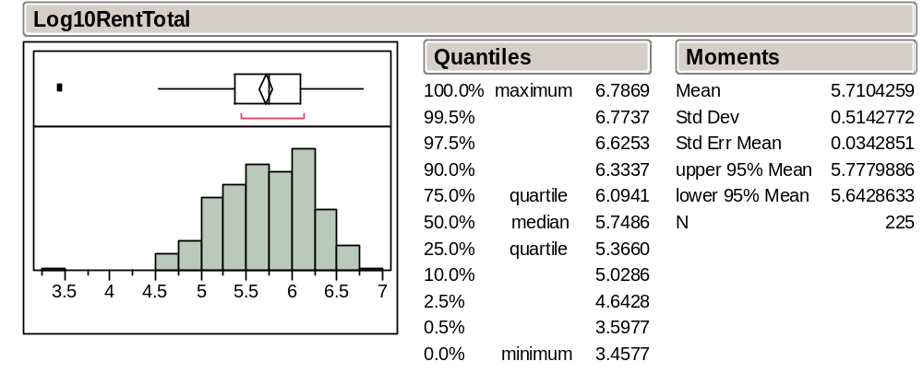

3. The time series plot of price shows strong meandering.

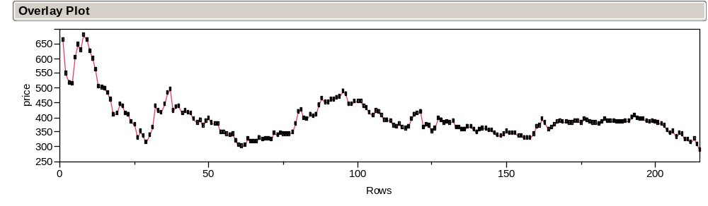

The summary statistics of price hide this meandering. They are not especially useful:

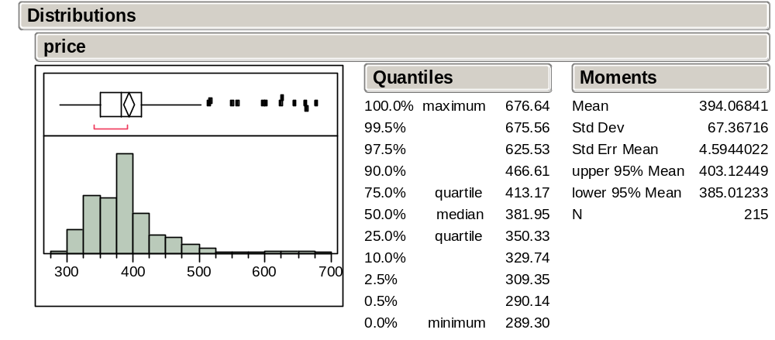

In contrast to price, the time series plot of pctchange reveals no meandering. This variable behaves approximately like a sequence of independent draws from a population (except for a decrease in variability towards the end of the series).

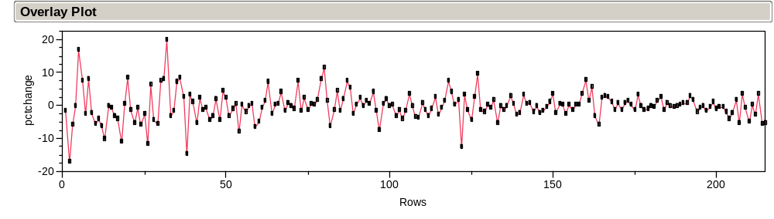

The normal quantile plot below shows, however, that pctchange is unlikely to follow a Normal distribution: the points wander above the upper red dashed curve on the left and below the lower red dashed curve on the right. Overall, the normal quantile plot approximates the shape of an inverted letter S, an indication of a population with heavier tails than a Normal distribution. Heavy tails are also visible in the histogram. In retrospect, the culprit is most likely the non-constant variability over time: the early periods contribute the heavy tails with widely fluctuating values, while the later periods contribute mostly the highly concentrated values near the center. We report basic numeric summaries but we won’t expect the empirical rule to hold well for these percentage changes.

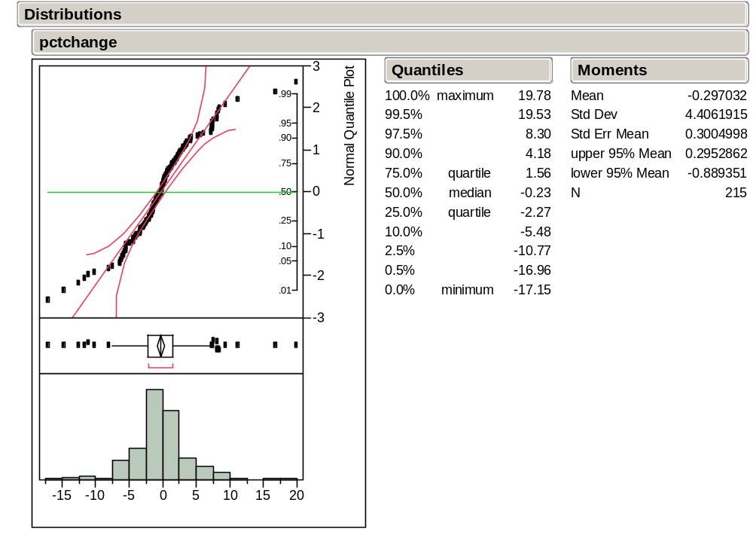

4. Forecasting Sales: The file Fields.jmp contains quarterly dollar sales (in $1000) of Marshall Field & Co, a large Chicago department store, for the 1st quarter of 1960 to the 4th quarter of 1975.

- Create a time series plot of Sales (Graph > Overlay Plot; Sales; Y) with connected points (red diamond > Connect…). Does the data look like a random sample, or does it show the meandering appearance of dependence? How would you describe the variation in Sales over time?

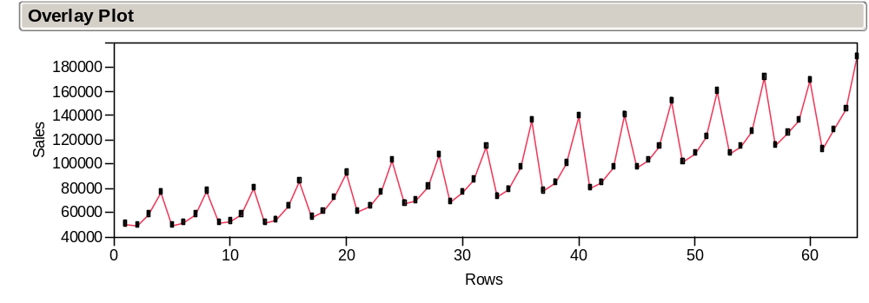

No, the data does not look like a sequence of independent draws from a population, i.e. a random sample; instead it displays the meandering appearance of dependence. Other features it has are inconsistent with the appearance of a random sample are an upward trend, increasing variance and a repeating pattern.

- Color the points according to the variable Quarter (Rows > Color … by Column > Quarter; if the points are too small, do this: Ctrl-K > Graph Marker Size > Large). Describe the appearance of these markers in the plot. Is there evidence of seasonality? Does it make sense? Explain.

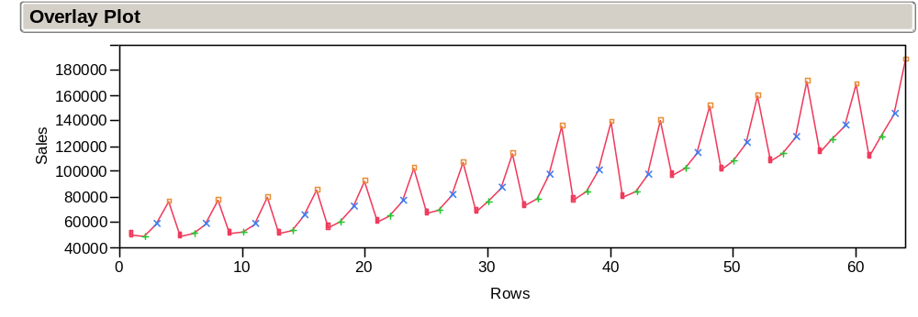

By putting the markers on the plot, one can see that consistently from lowest to highest are quarter 1, quarter 2, quarter 3, and then quarter 4. This is strong evidence of seasonality, namely, a systematic seasonal effect. The observed seasonality also makes good sense; traditionally, the 4’th quarter experiences the largest number of sales (due to year-end holidays).

- Create numerical and graphical summary statistics for Sales (Analyze > Distribution > Sales). Do these statistics give a misleading picture of what happened to Sales from the 1st quarter of 1960 to the 4th quarter of 1975? Explain.

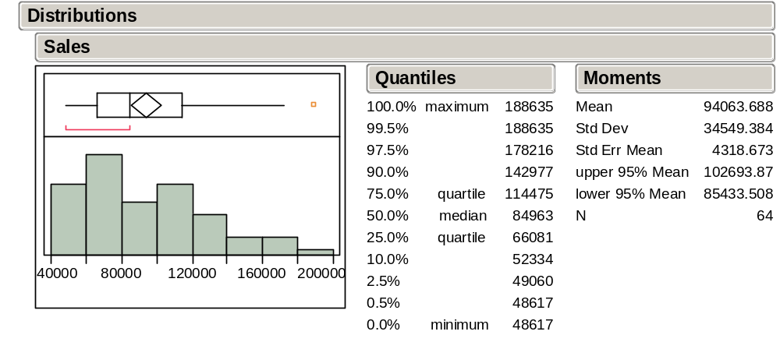

Yes, these statistics give a misleading picture because they mask the seasonal effect and blend out the upward trend over time.

- Would it make sense to predict Sales in the 1st quarter of 1976 by the mean of Sales? Explain.

No, it would not make sense. Sales in the 1st quarter of 1976 will tend to be closer to the more recent values than the earlier values. Clearly, the overall mean of Sales would probably be too low because of the upward trend.

- Create a new column containing the quarterly relative changes of Sales, name it “Rel_Sales”, and define it by the formula (Sales - Lag(Sales, 1)) / Lag(Sales, 1). (Execute: Cols > New Column; Column Name: Rel_Sales; New Property > Formula; click first Divide, then Subtract, on the operations pad; fill in the first field Sales, in the other two fields Functions: Row > Lag > Sales.) What does Lag(Sales, 1) represent? Why is the first value of Rel_Sales missing?

The variable Rel_Sales can be found in the file Fields-more.jmp. Right-click on the variable Rel_Sales and select Formula to see how this variable was defined. Lag(Sales, 1) represents the sales of the previous quarter. Using the subscript notation from class, if the value of Sales at time t is denoted by S_{t,} then the value of Lag(Sales, 1) at time t is denoted by S_{t-1}. The first value of Rel_Sales is missing because it has not lag value.

- Create a connected time series plot of Rel_Sales, as before for Sales. Does the data look like a random sample, or does it show the appearance of sequential dependence? Do the markers still indicate evidence of seasonality? How would you describe the variation in Rel_Sales over time?

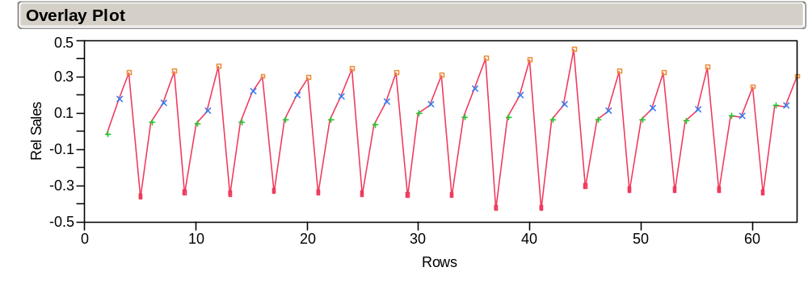

The trend and increasing variation of Sales are no longer present in Rel_Sales. However, the seasonal effect remains. The markers reaveal that Rel_Sales is lowest for quarter 1, and highest for quarter 4. Quarter 3 is consistently higher than quarter 2.

- Plot Rel_Sales versus Quarter (Analyze > Fit Y by X; Rel_Sales > Y; Quarter > X) and augment with comparison boxplots (red diamond > Display Options > Box Plots). Now this plot captures the essence of the data! Describe what it tells you about seasonality.

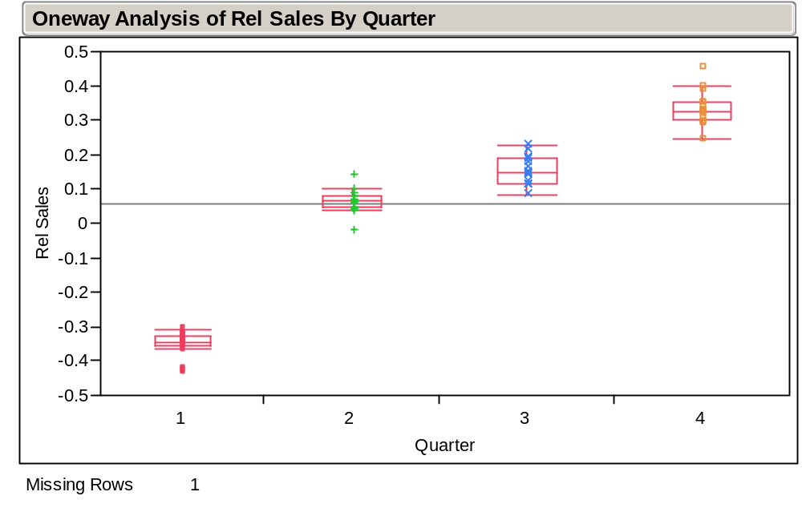

The plot summarizes the seasonality observed in the plot in part (g). The boxplots show that the relative changes from quarter to quarter stay within a narrow range. The boxes are quite distinct for the four quarters. The relative change from quarter 4 to quarter 1 is consistently the lowest, by far. The relative change from quarter 3 to quarter 4 is consistently the highest, by far.

- As a refinement of the insights gained in the previous plot, obtain numerical and graphical summaries of the values of Rel_Sales grouped by season (Analyze > Distribution; Rel_Sales > Y; Quarter > By).

See the last page for summaries grouped by season. (The horizontal layout can be obtained by setting File > Preferences > Platforms > Select a Platform: Distribution; Options: check Horizontal Layout.)

- Predict Rel_Sales in the 1st quarter by the mean of the 1st quarter Rel_Sales values. Does this seem reasonable?

Using the mean of 1st quarter Rel Sales, we would predict Rel_Sales in the 1st quarter of 1976 to be -.352533. Yes, this seems reasonable.

- Use your answer to (i) to predict Sales in the 1st quarter of 1976.

(Sales in 1st quarter of 1976 – sales in 4th quarter of 1975)/(sales 4th 1975) = -.352533 (the left-side is just from the definition of Rel_Sales; right-side from (i)). From the data, the sales in 4th quarter of 1975 were 188,635, so the predicted sales for 1st quarter of 1976 is
(1 + (-.352533))(188,635)=122,135.

4 f) output
